# Urban Gardens, Website Proposal

## Created by Justin Prohaska March 2020

# Background:

Urban gardens is a Family owned business created in 1975 The business specializes in developing gardens and landscaping in urban areas. They are known specifically for their rooftop garden designs and have won several design awards in urban design and landscaping. They have many projects under their belt, one being the award-winning flower decorations in South Park Located on the south east side of Chicago Ill.

# Customer base:

Although Urban Gardens specializes in Developing urban areas their expertise can be employed just about anywhere and by anyone. Possible customer base could include but is not limited to families, businesses, nonprofits, charities, city work, or anyone with landscaping needs.

# Site objective:

The goal for the Urban Gardens site is to provide an official yet friendly presence on the web that makes it easy for customers to get in touch and view all the different type of work that Urban Gardens has done. Urban Gardens would also like to show off their services, products and staff.

# Pages and Functionality:

* **Home:** The home page needs to showoff some of their best rooftop designs using a rotating slider. The page also needs to have a short introduction of the business and information about their location. They also want a Search field, navigation leading to the services, products and contact pages as wall as information about their location (Chicago Ill.)
* **Services:** The services page will show a list of services and a list of the staff with a small picture.
* **Products:** The product page will be a gallery showcasing all the different products that Urban Gardens sells.
* **Contact:** A standard contact form where people can ask questions and get in touch with the business.

# Sites to emulate:

1. **Dogpatch Urban Gardens**

Dog patch has an incredible and simplistic site that does a great job of showcasing their projects. They are also a family run business and their site really shows it.

<https://www.dogpatchurbangardens.com/#dogpatchurbangardens>

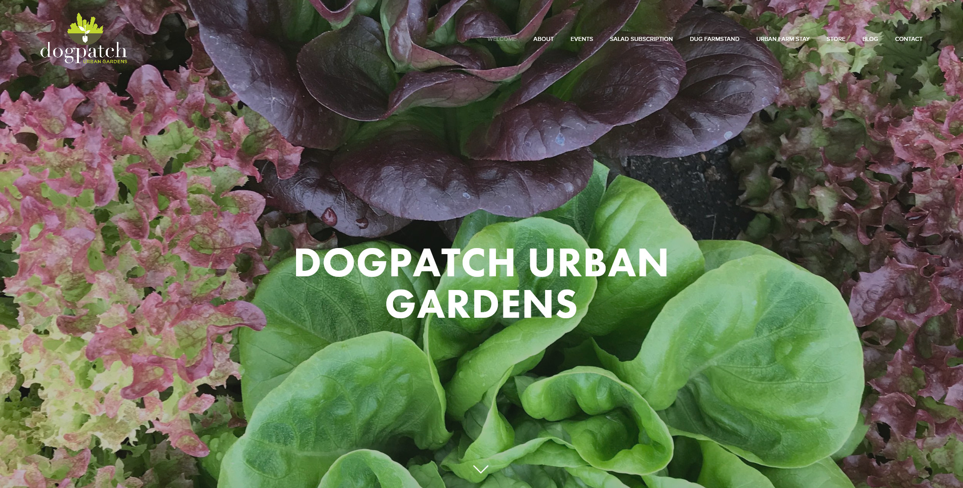

1. **Bonnie Plants**

[**https://bonnieplants.com/**](https://bonnieplants.com/)

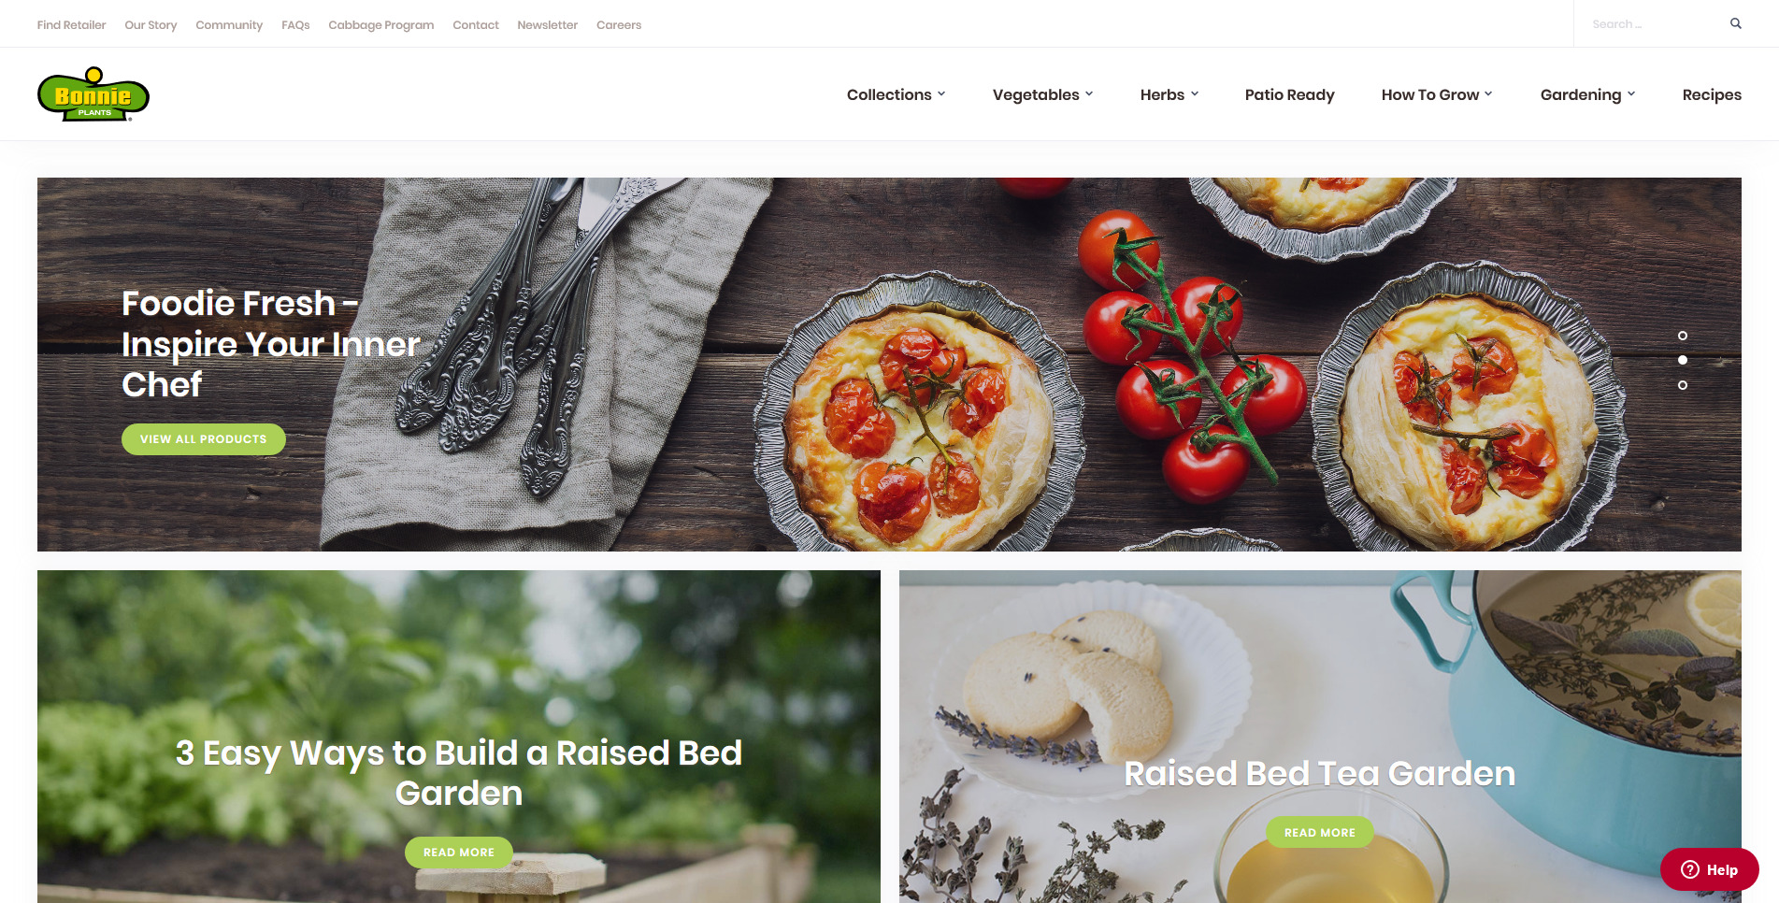

Bonnie plants is a nice down to earth web site that is easy to navigate and very visitor friendly. This site give away a massive amount of free information while showcasing their new application for download.

# Execution:

This site will be created in Wordpress after an extensive search for the right theme. Urban Gardens is willing to pay the fee for any premium theme that fits the site profile. After a short learning curve The owners will be able to add and alter content at their leisure. A color pallet will be carefully chosen for this site that fits in the motif.